1st Quarter 2018 Goals Agenda

December 8th 7:30am – 3:00pm

* 7:30am Breakfast
* 7:45 – 7:50am **Safety Message**
* 7:50 – 8:00am Mark S. Smith & Ann R. Lewis – Meeting Kick-off
* 8:00 – 8:15am Mergers & Acquisitions Team– Sameer Raval
* 8:15 – 8:30am Mobile Enablement Team – Joe Vincent
* 8:30 – 8:45am GIS Team – Jeff Brill
* 8:45 – 9:00am Service Management & Compliance Team – Howard Mundell

* 9:00 – 9:15am Core Collaboration Team – Naveen Bhimasenachar
* 9:15 – 9:30am Converging Infastructure Team – Jim Champion
* Data Lake Infrastructure
* MSG- Military Services Group
* CSG- Contract Services Group

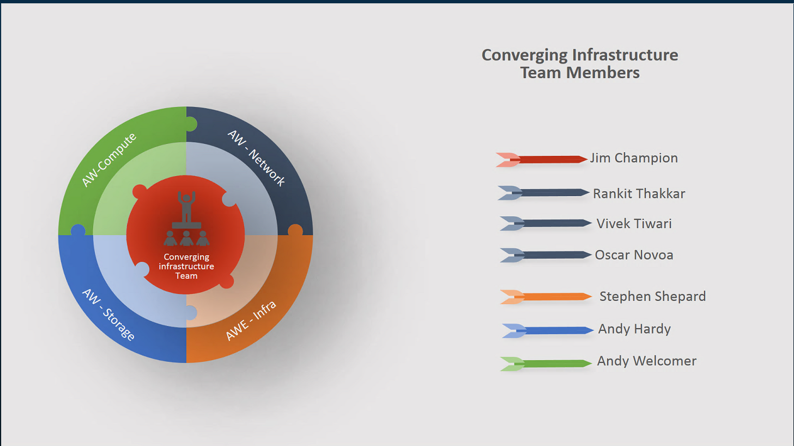

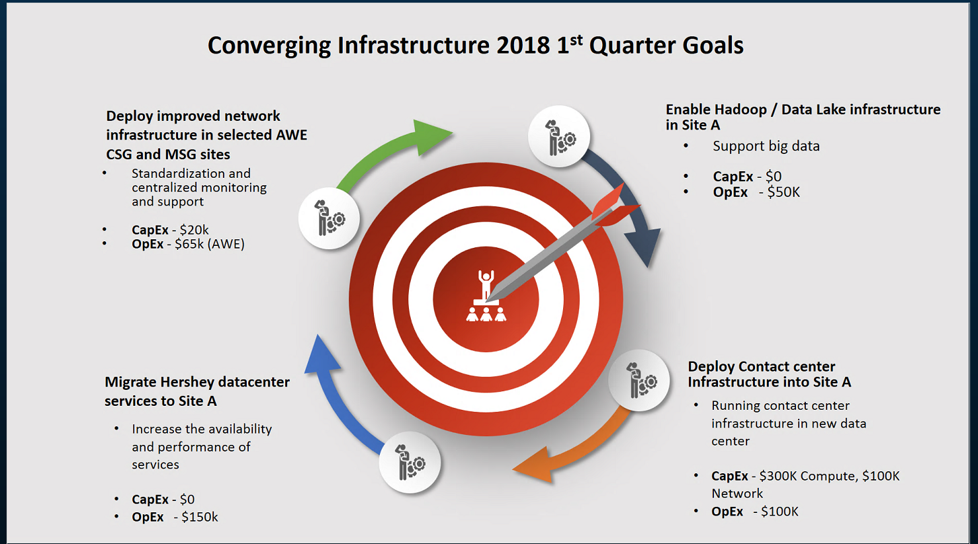

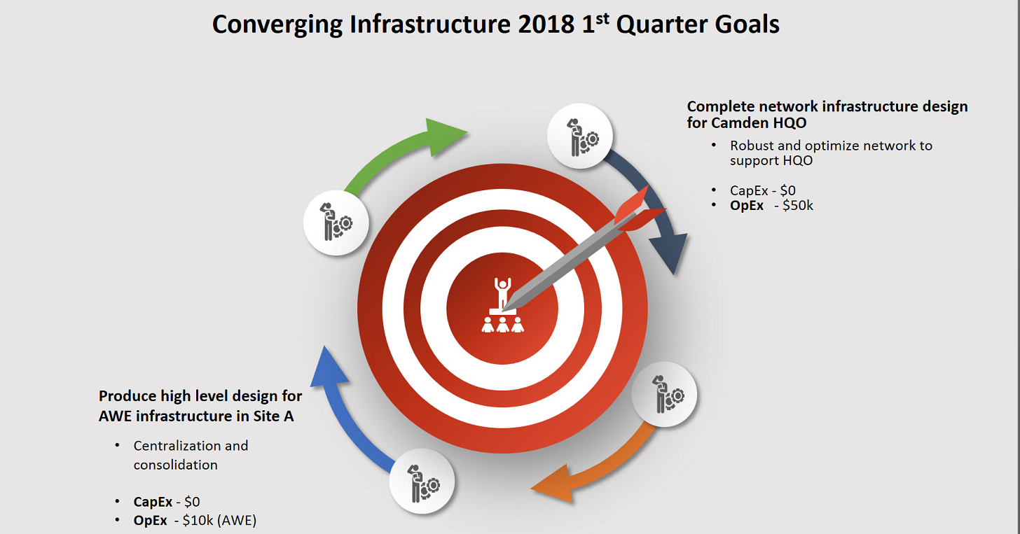

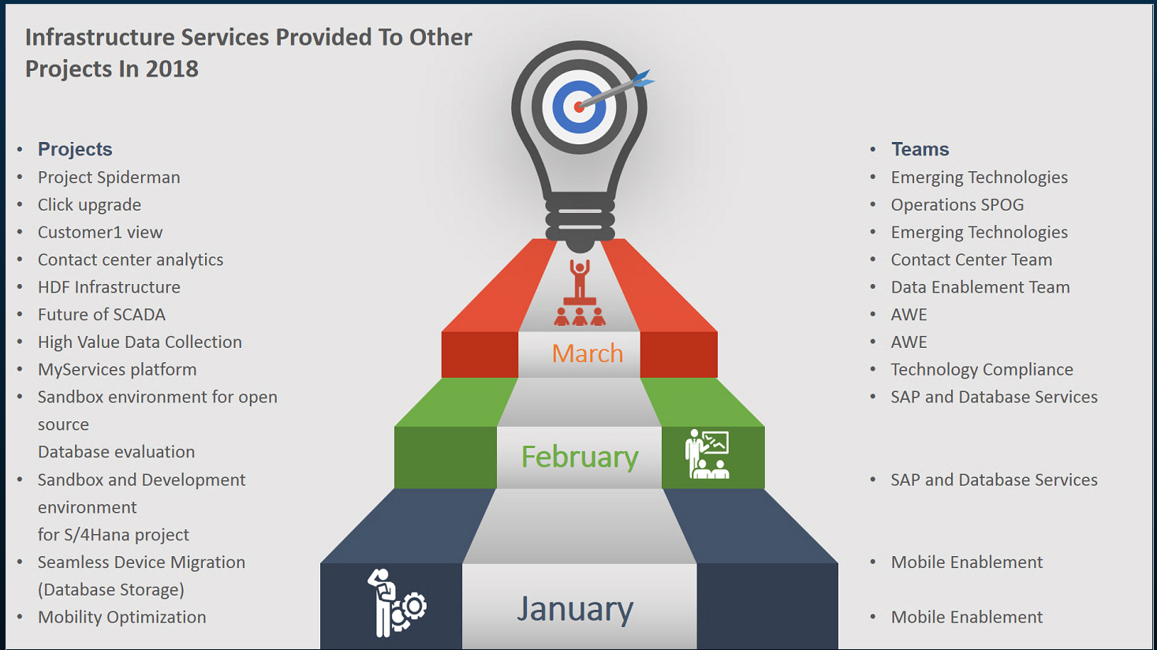

* 9:30 – 9:45am SAP Team – Jackie Reader

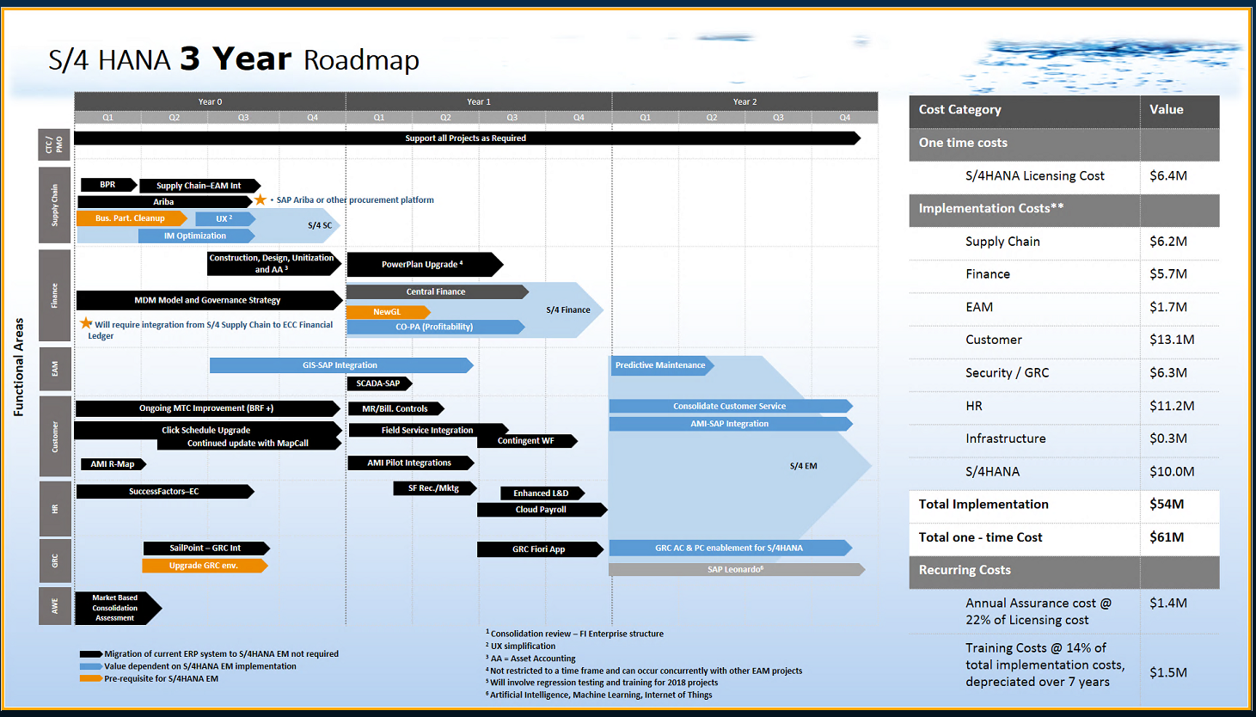

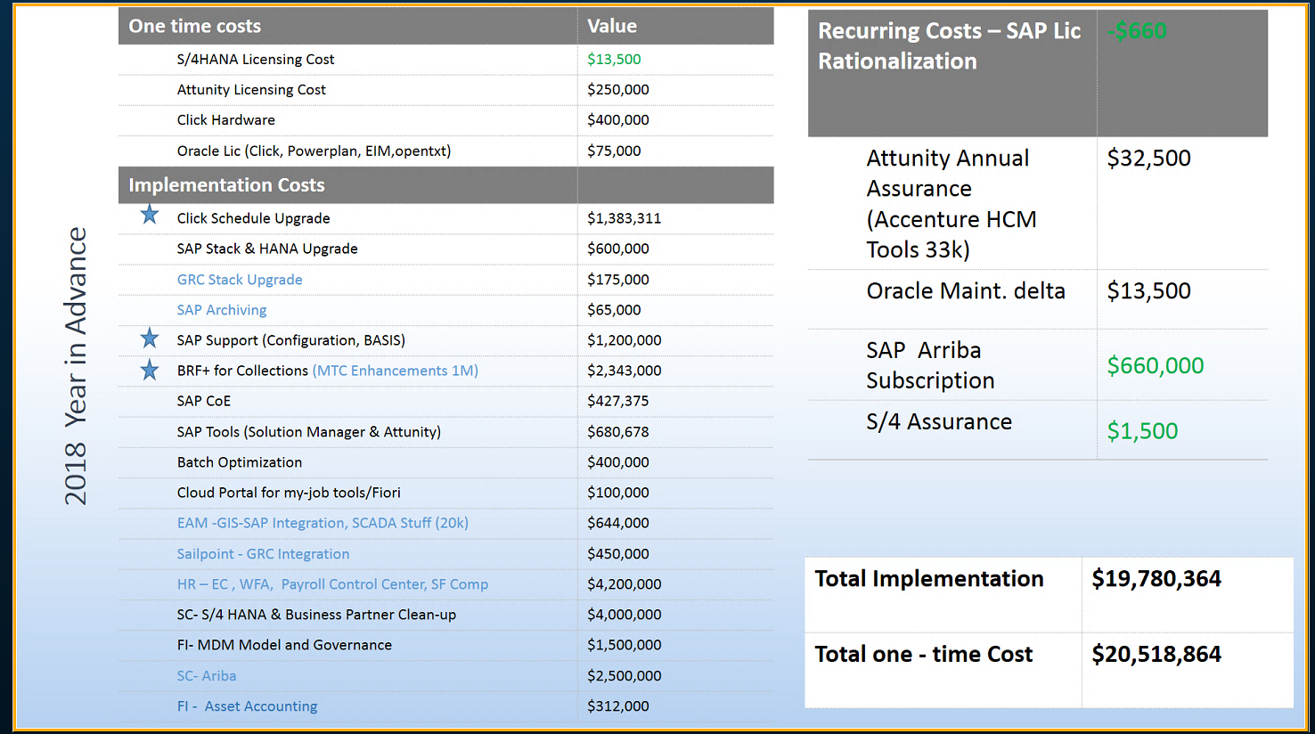

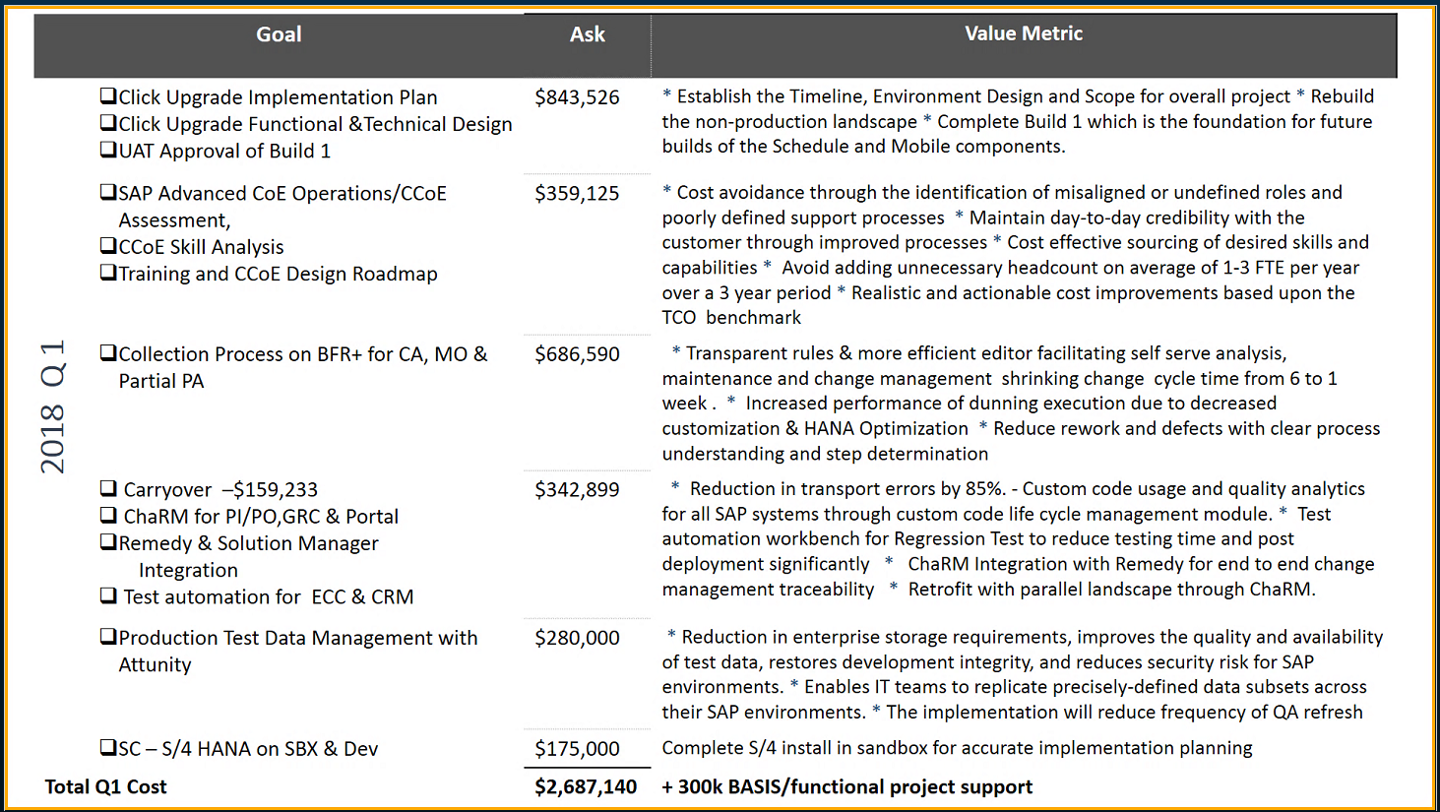

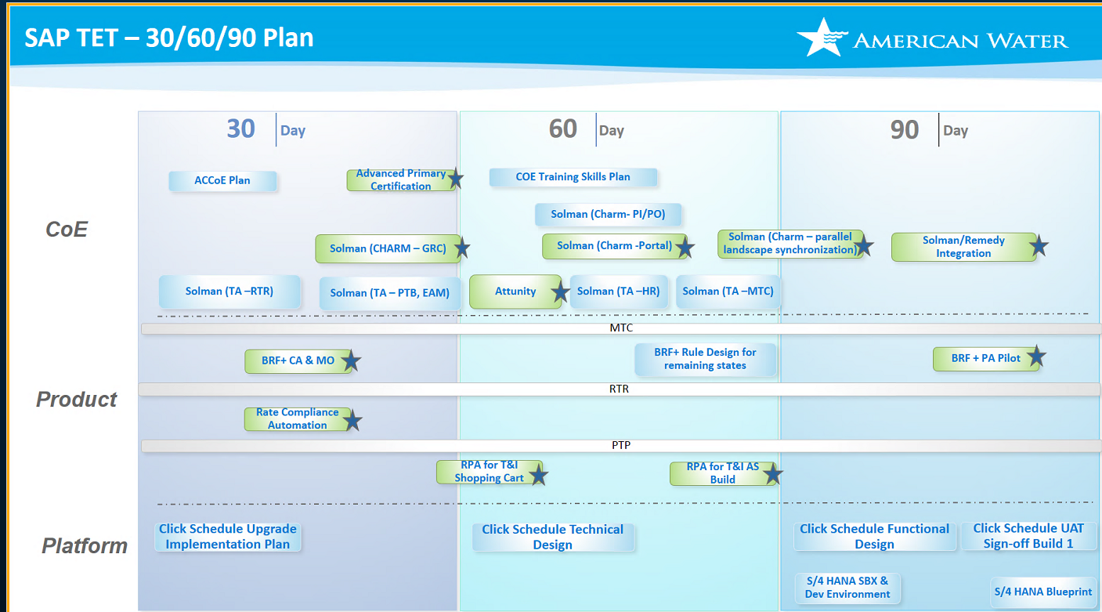

* 9:45 – 10:00am Integration Technology Team – Mike Leaning

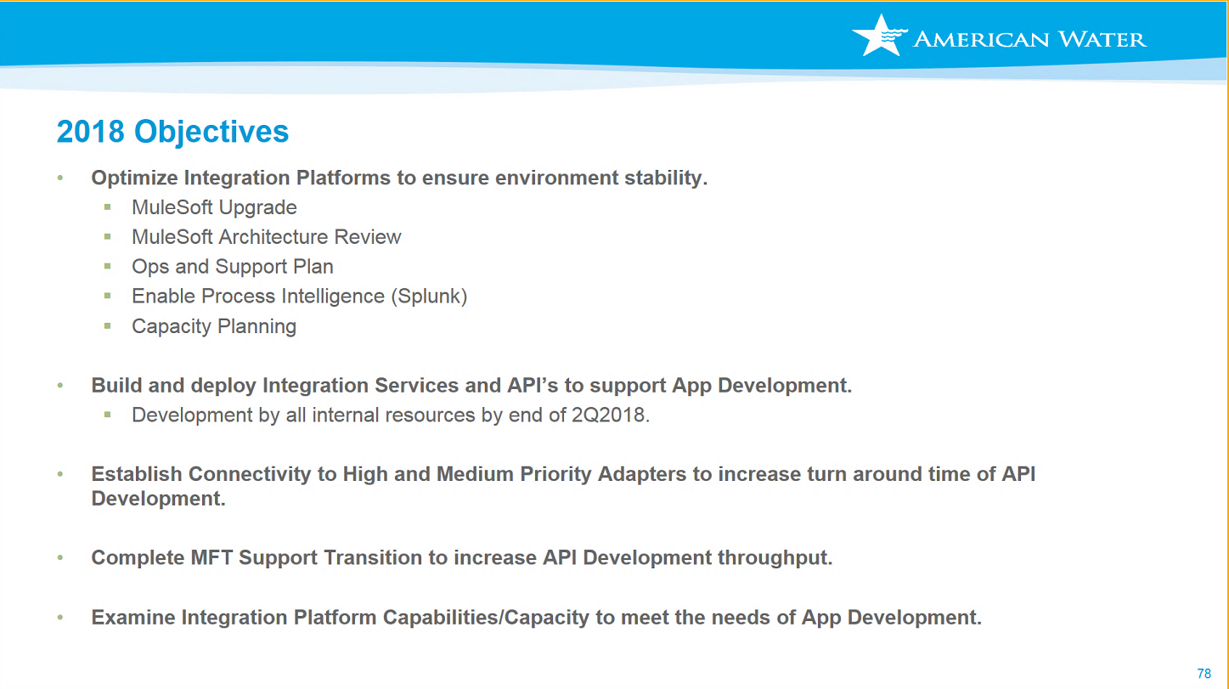

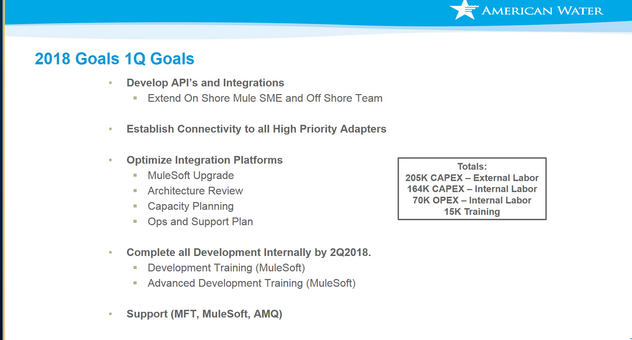

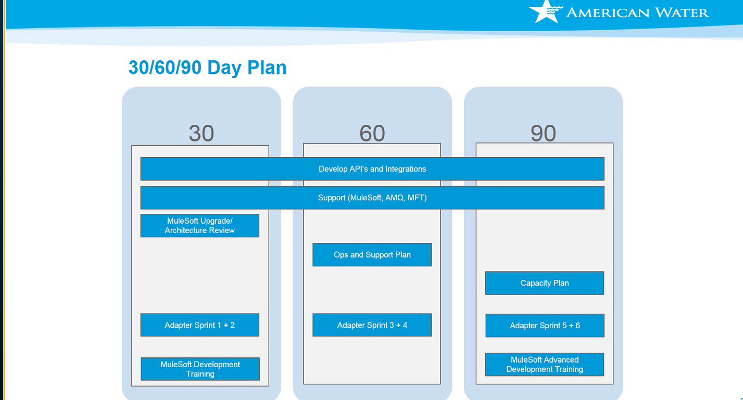

* 10:00 – 10:10 am **BREAK - 10 Minutes**

* 10:10 – 10:25am MIST Team – Ann Vanneman

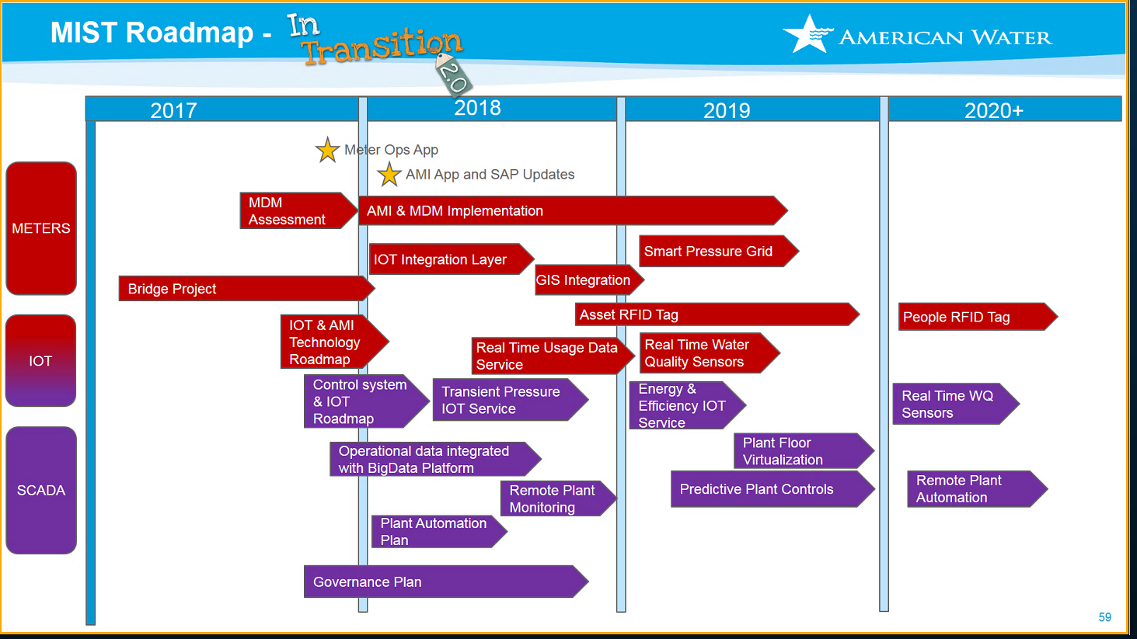

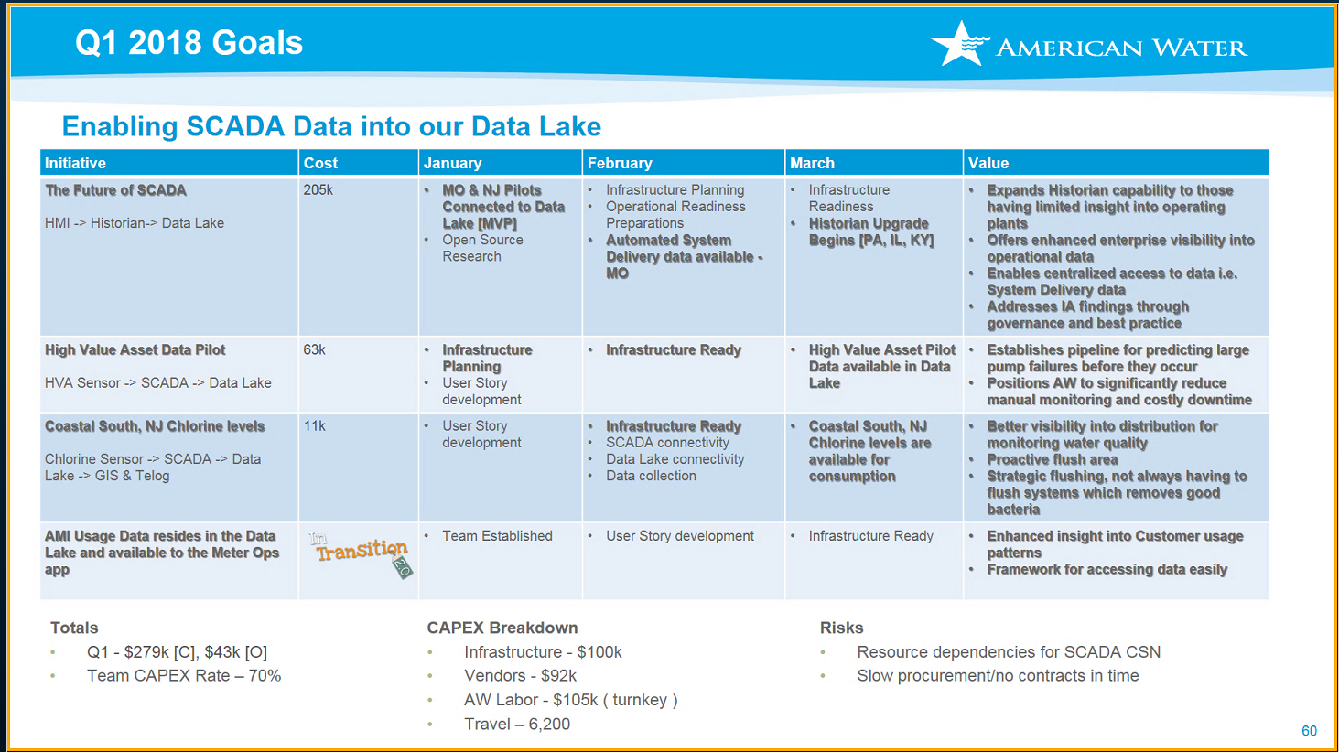

* 10:25 – 10:40am Data Enablement Team – Fred Lamb

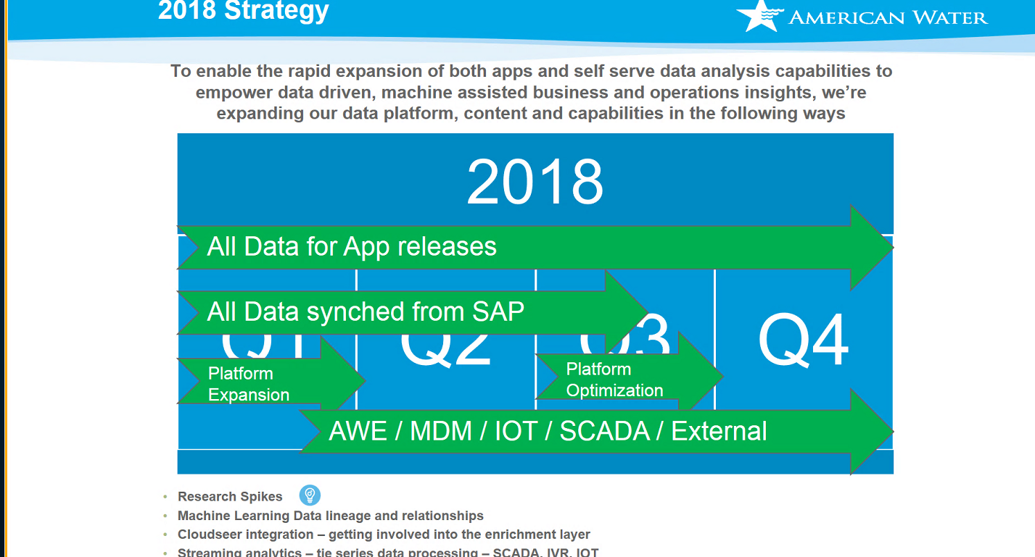

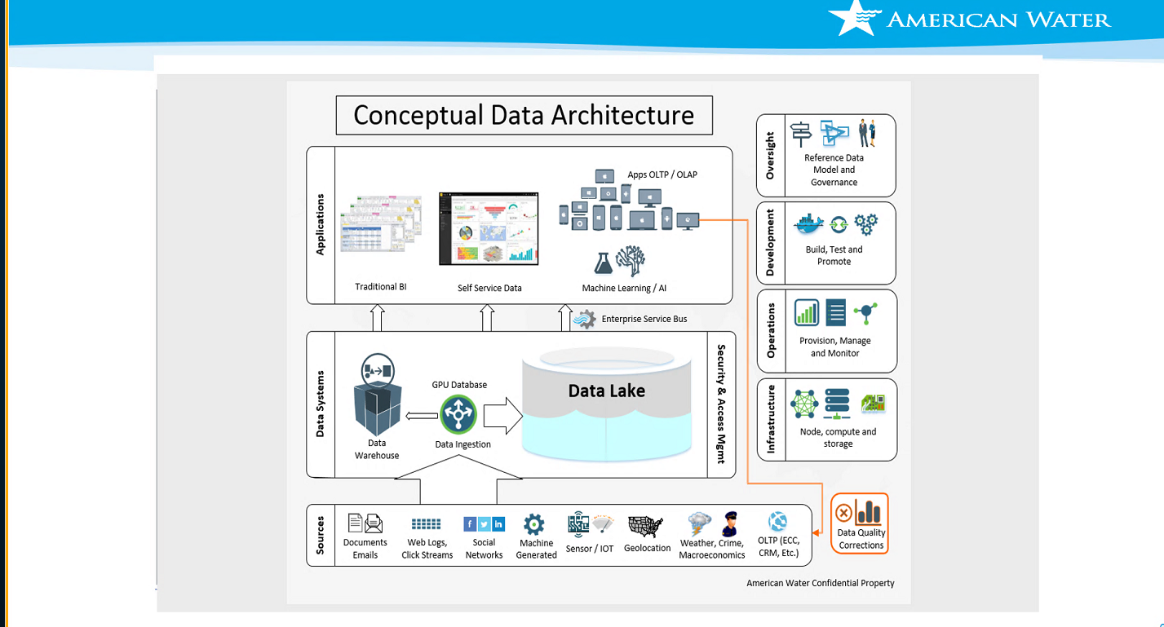

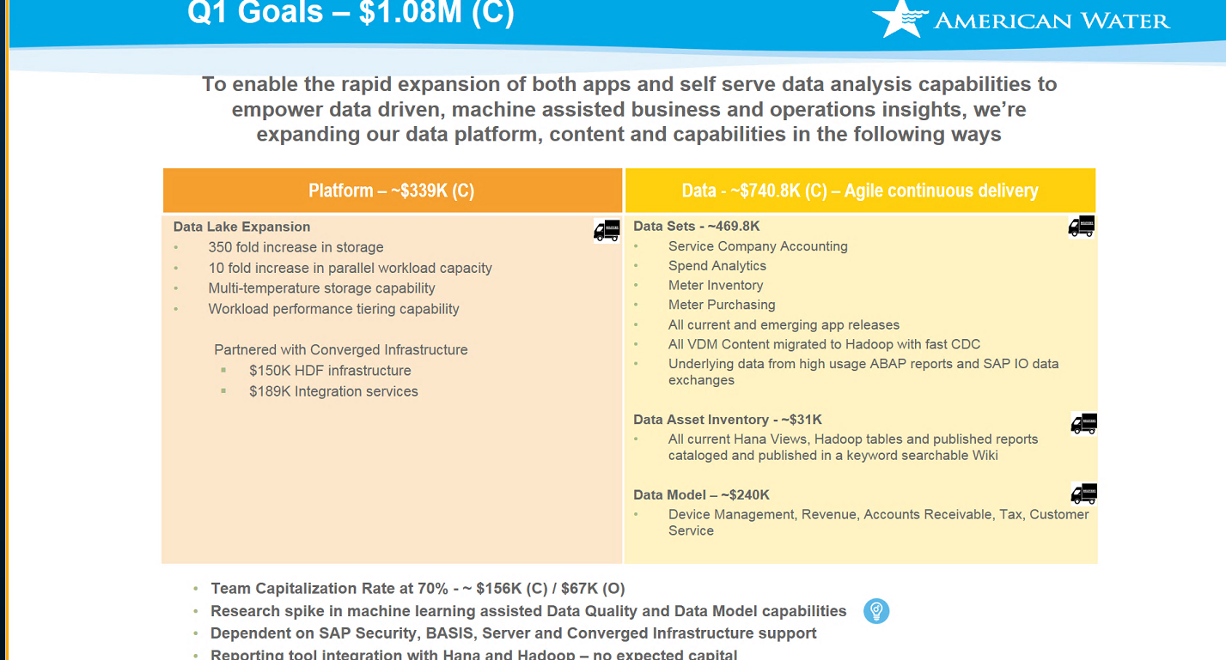

* 10:40 – 10:55am Delivery System Operations Team – LeighAnn Thomas  
   11:05 – Colin Campbell - Service Desk  
   11:10 - Mike Dexter - Computer Operations   
   11:15 – Mike Price - SAP & Database Services

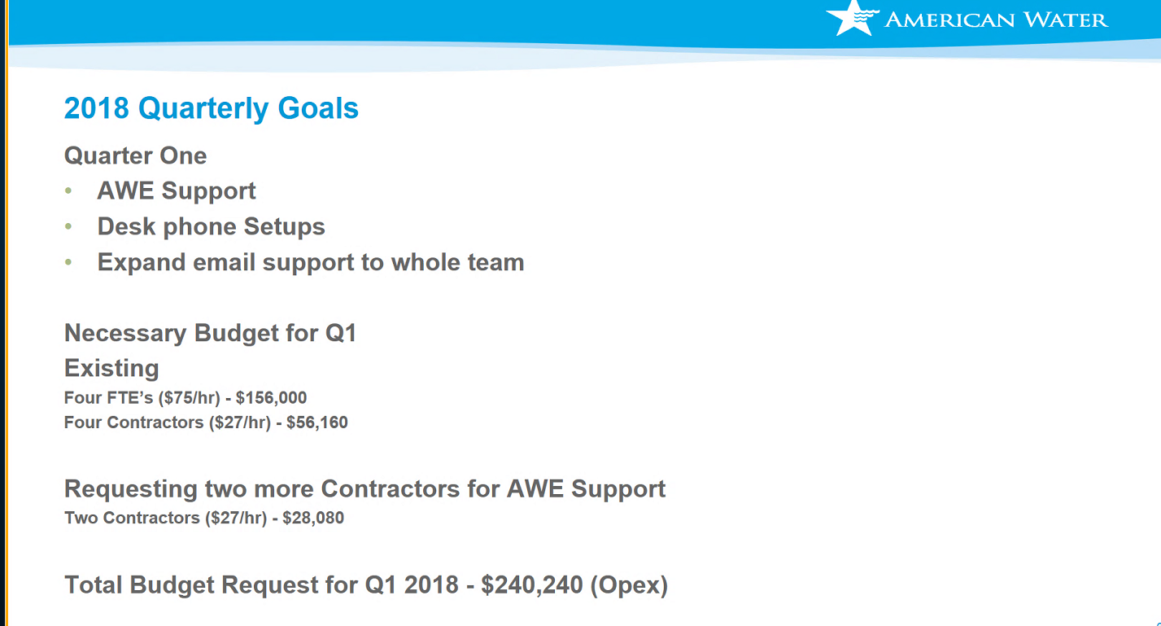



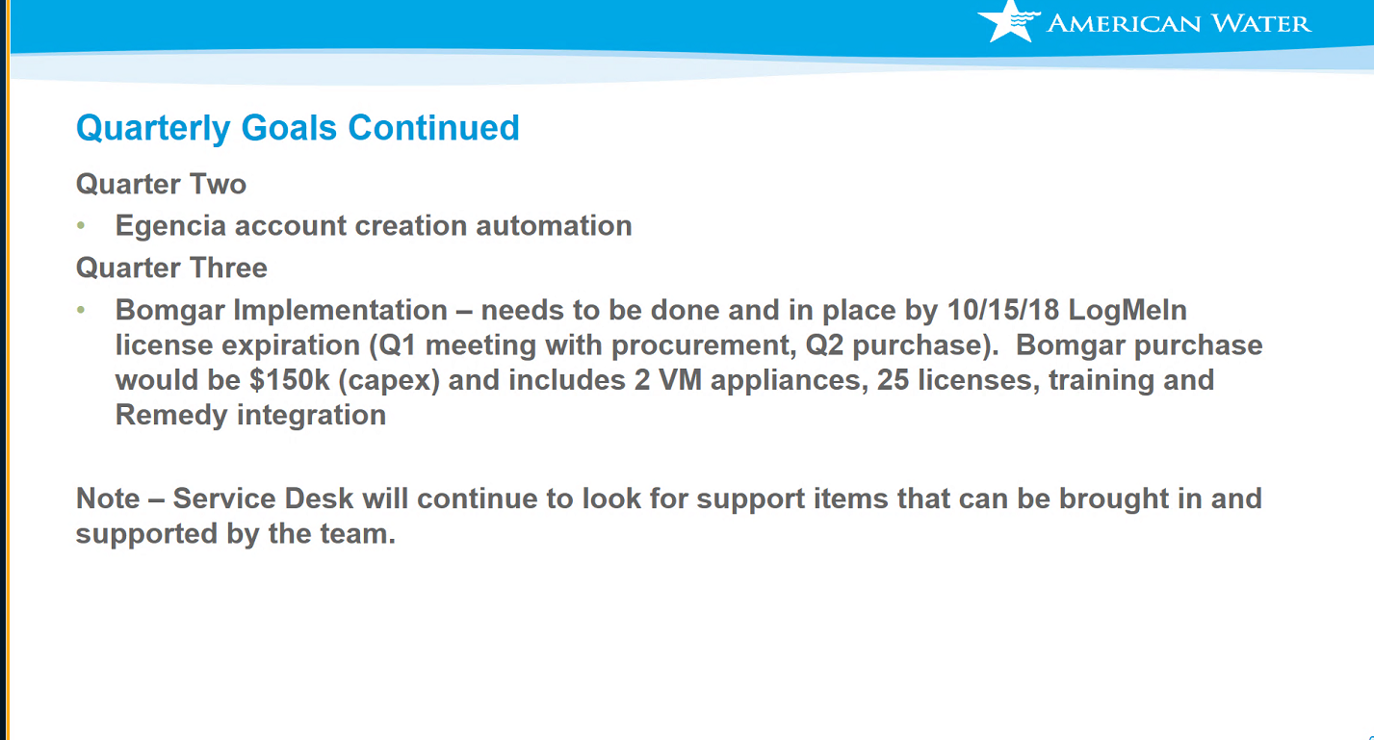

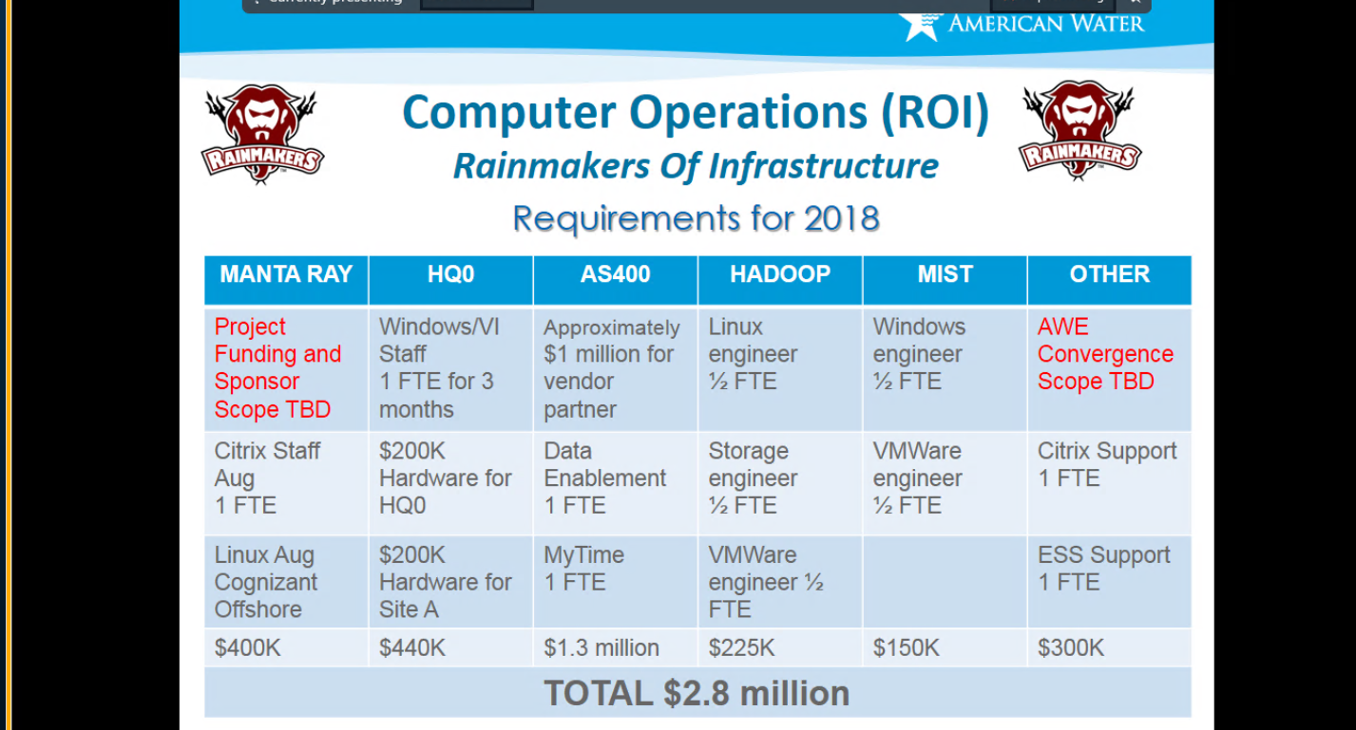

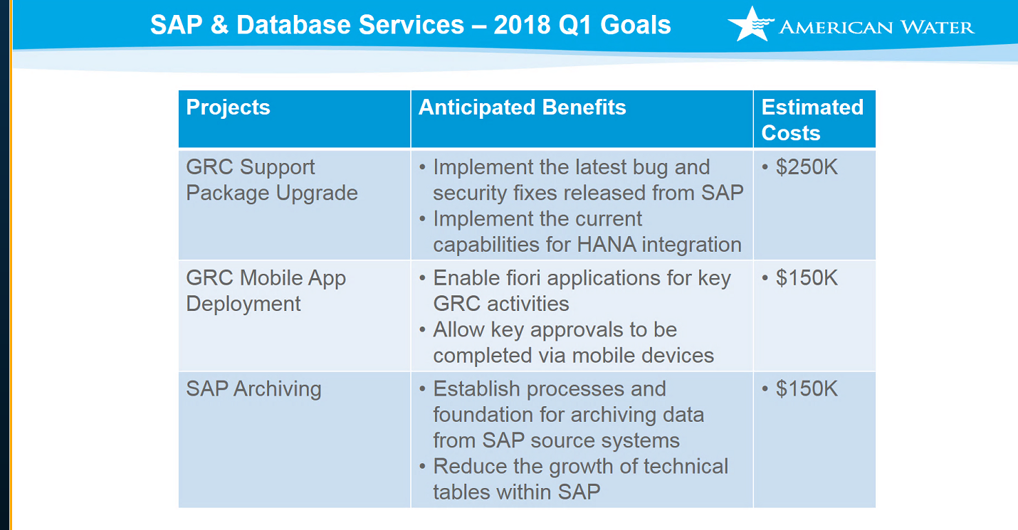

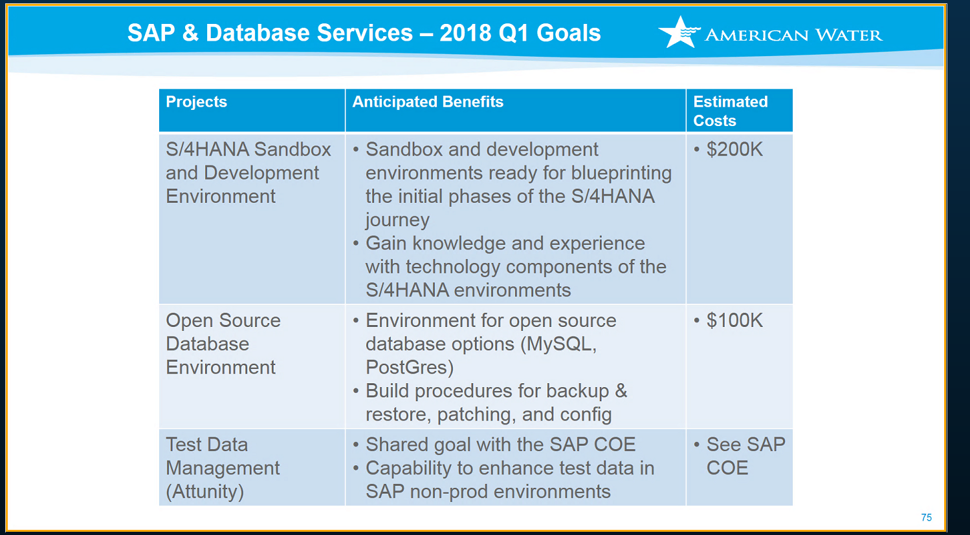

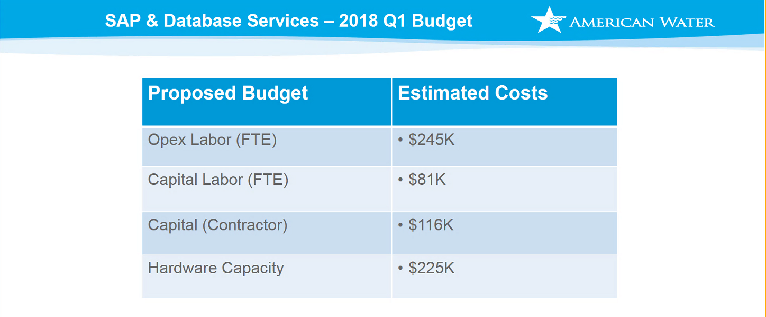

* 10:55 – 11:10am App Product Development Team – John O’Connor

1st Quarter 2018 Goals Agenda

December 8th 7:30am – 3:00pm

* 11:10 – 11:25am SPOG-Ops Team – Sebastian Jaison Caliankar

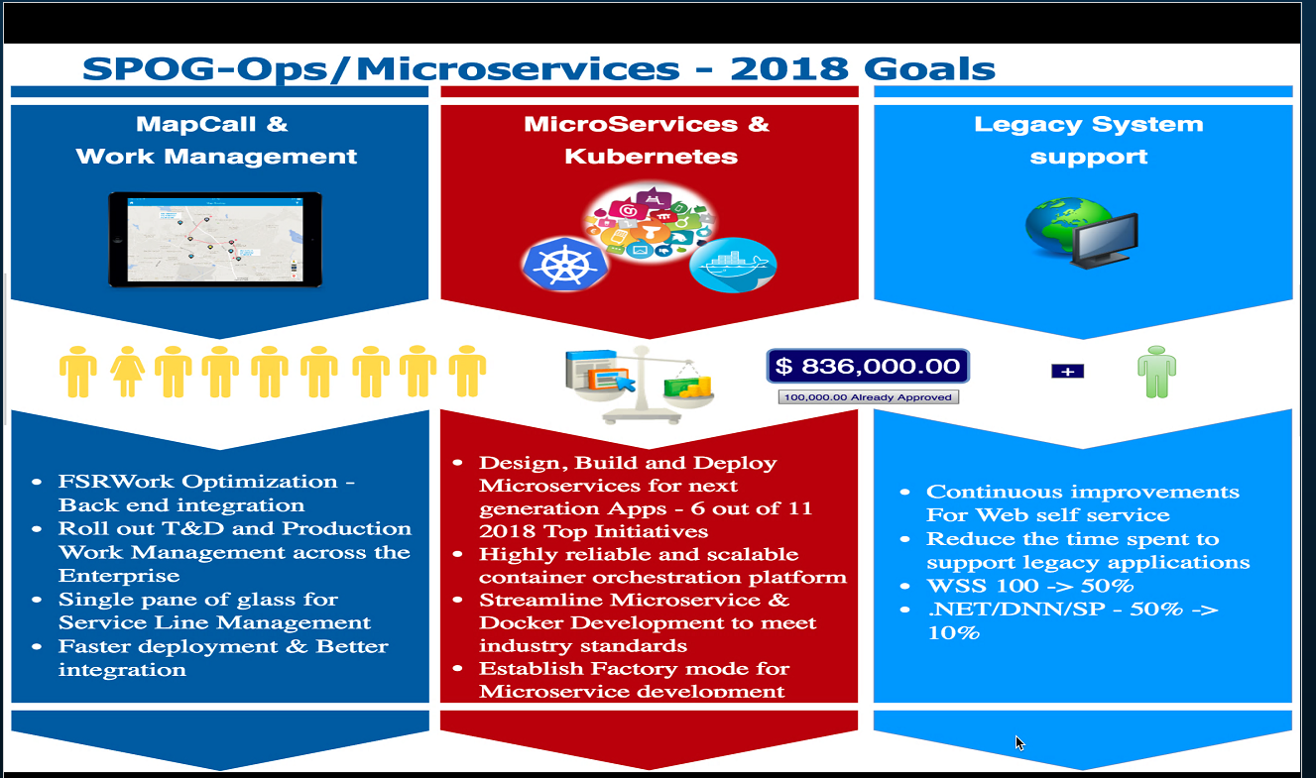

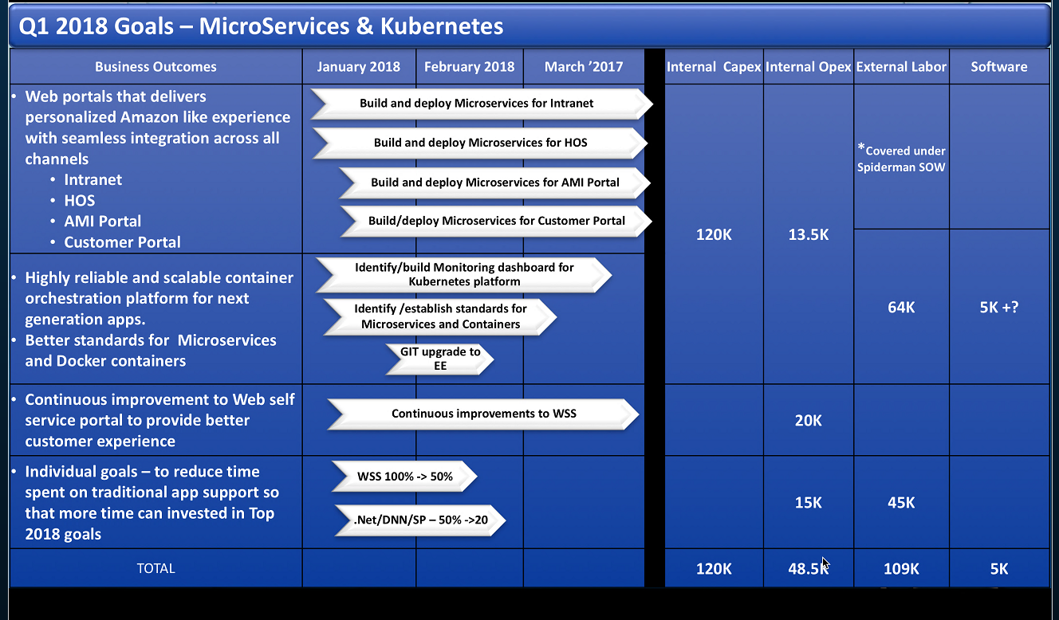

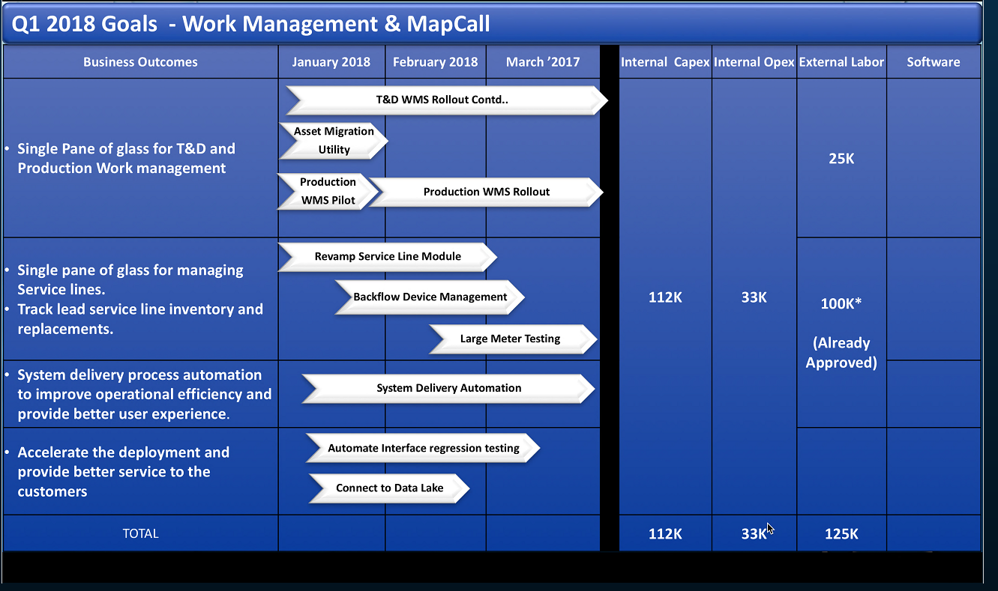

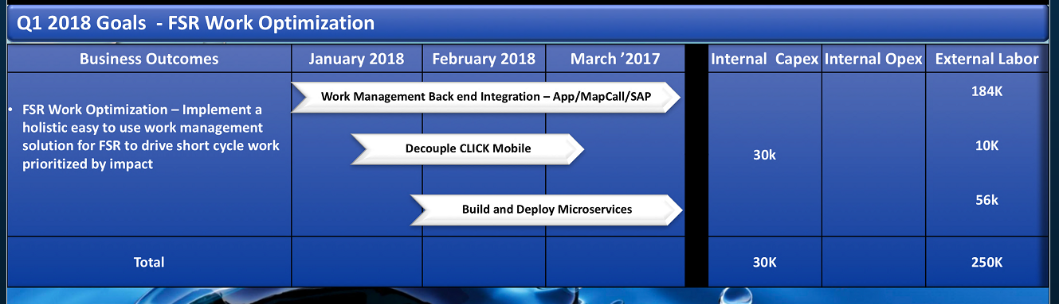

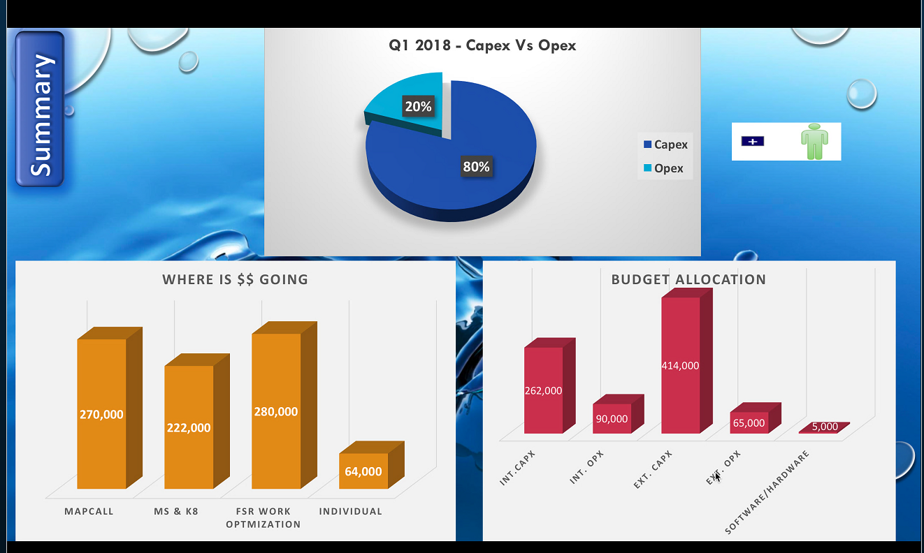

* 11:25 – 11:40am Mid-Atlantic/Southest Divisions Team/ Eastern Division Team   
   Midwest Division Team – Charles Leonardo

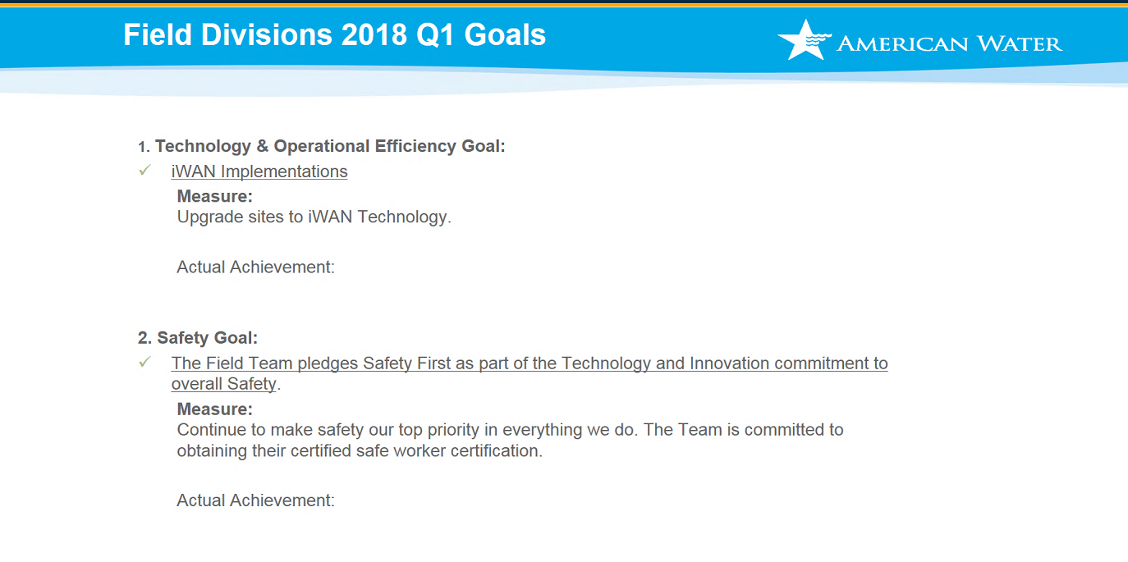

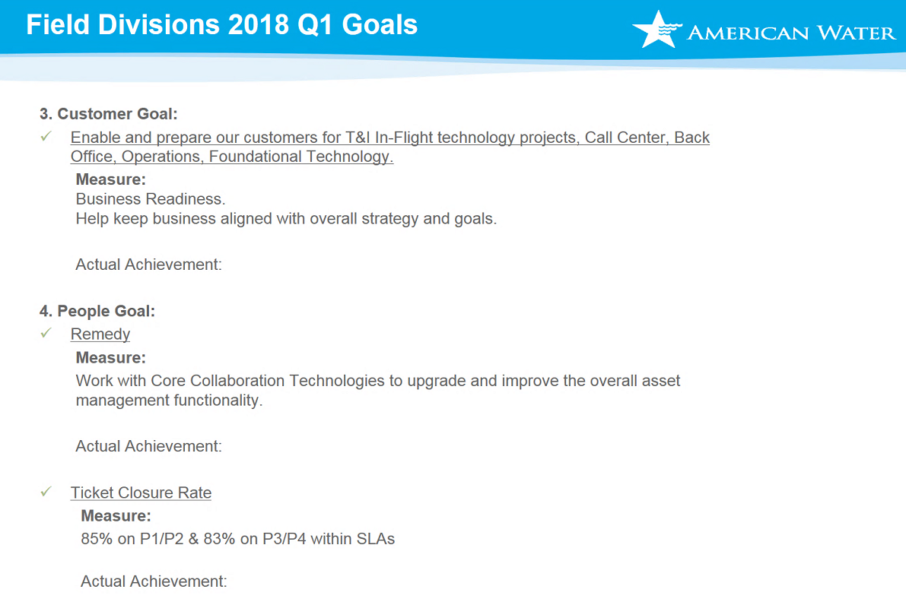

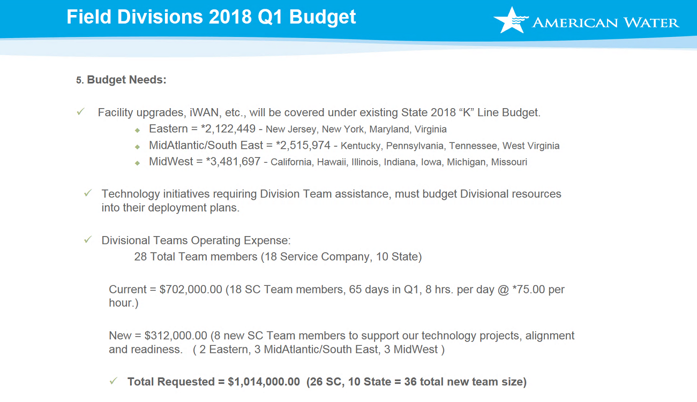

* 11:40 – 11:55am Finance & Supply Chain/myTime Team – Neeru Sharma

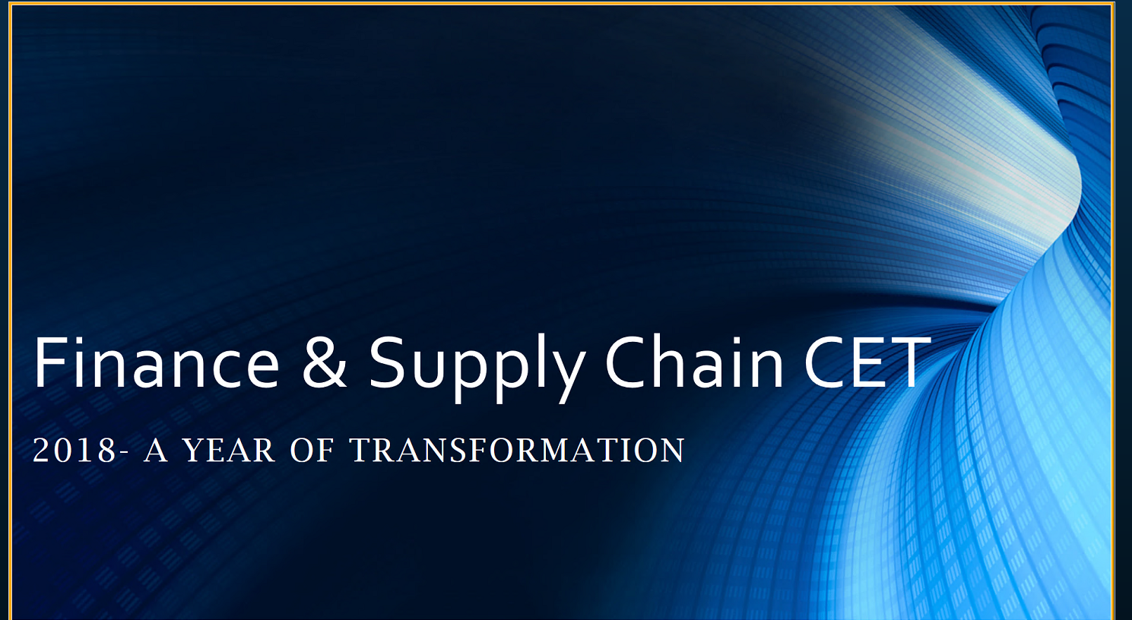

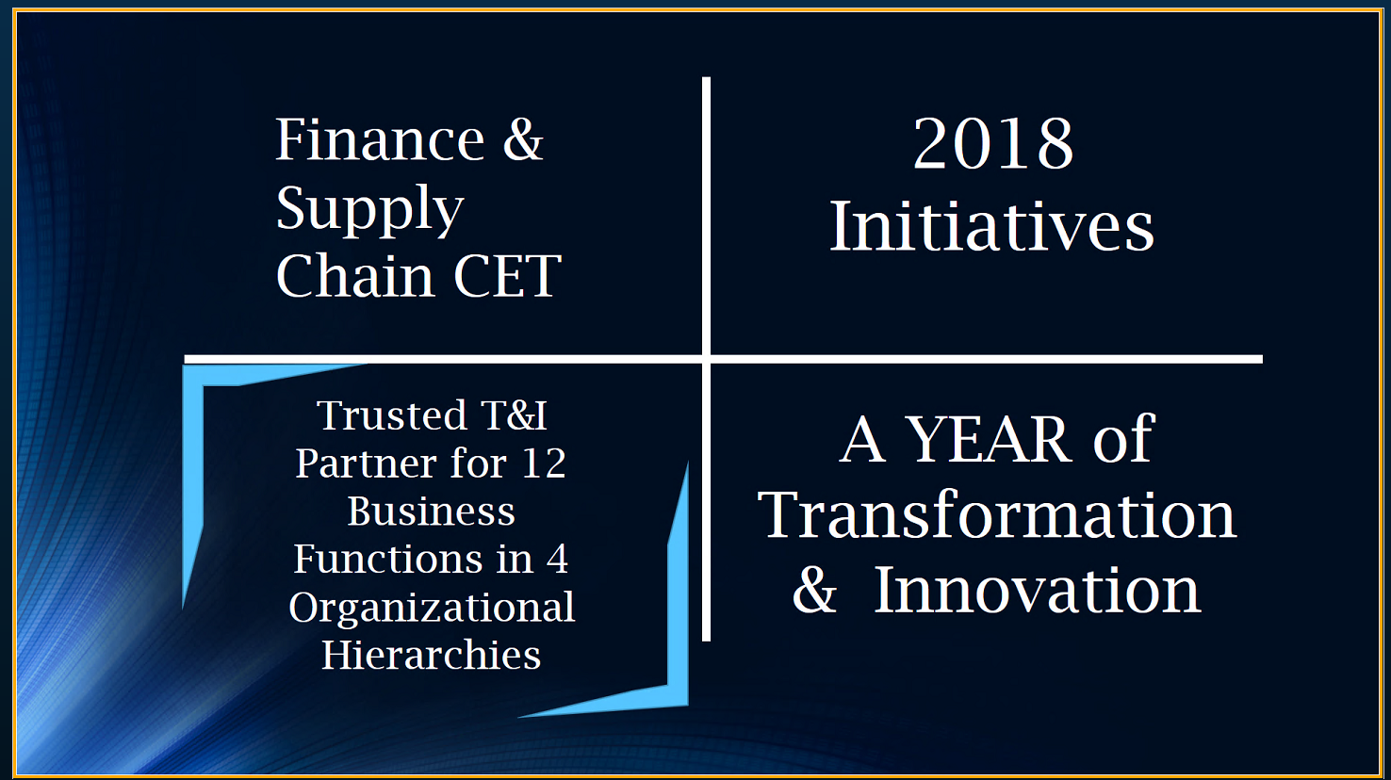

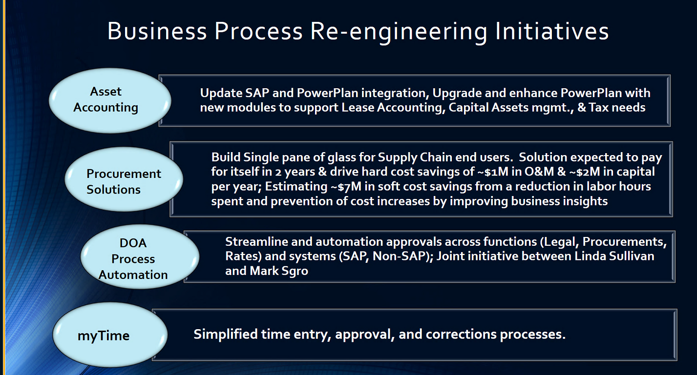

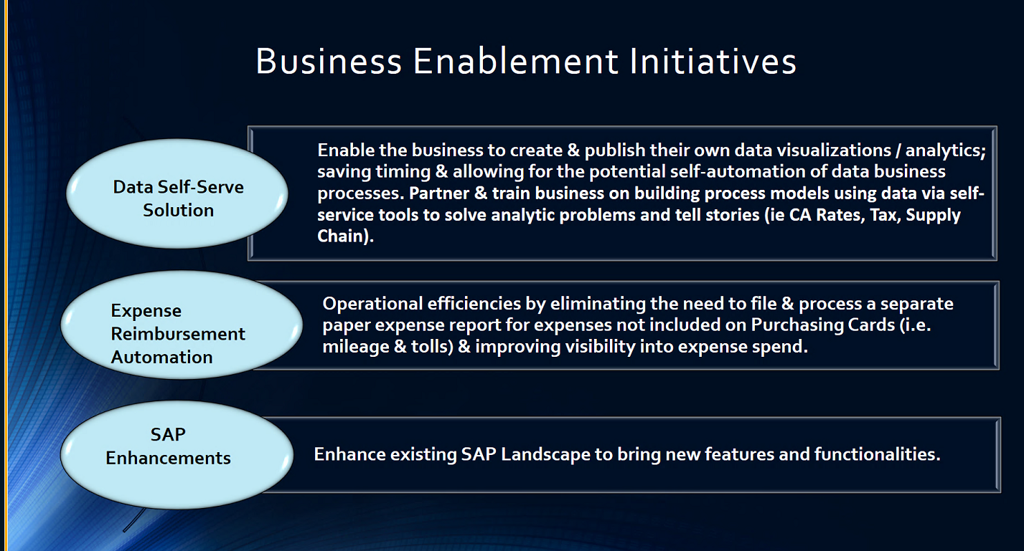

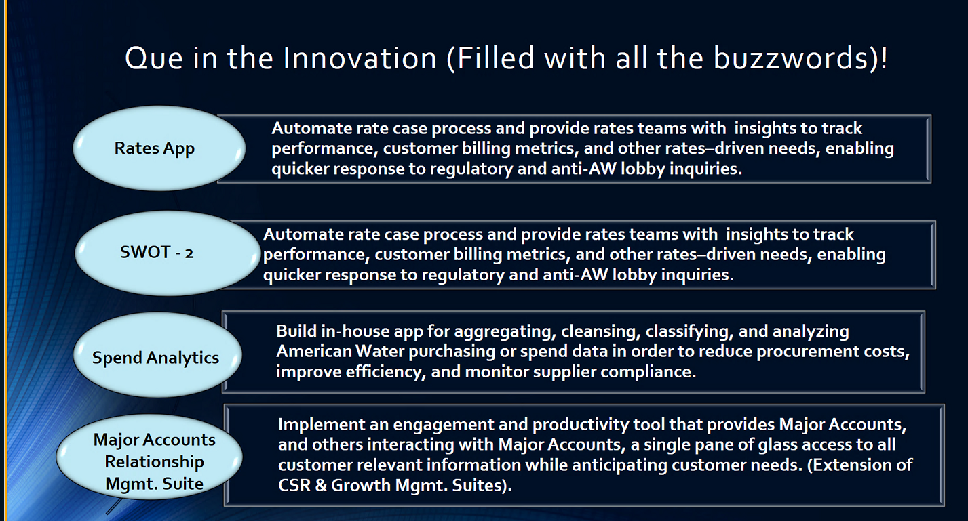

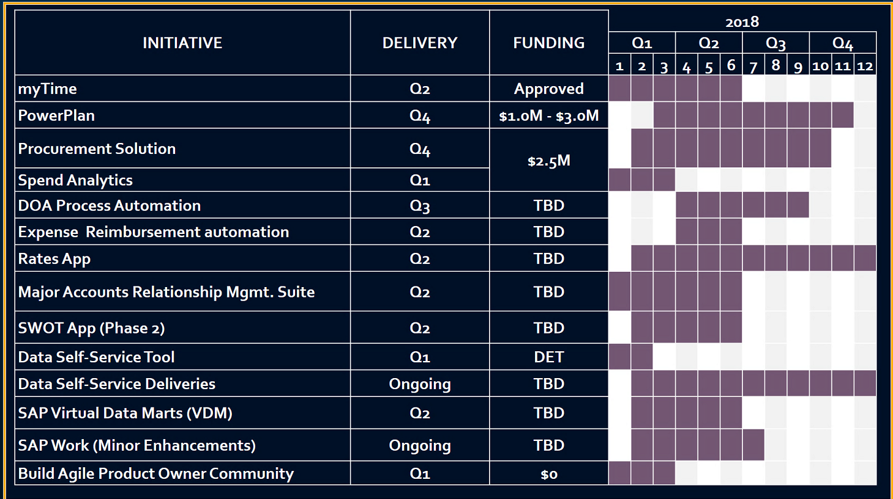

* 11:55 – 12:25pm **Lunch Break**